Using the blockchain explorer, have a look at the following transactions, what do they do ?

Transaction No 1

0xb9316bbbae1cd21cd824de8651c72582261230724b1957abdeb466aa96a359c9

Ans: This transaction simply seems like a transfer of tokens to DAO with transaction fees of 0.090681850491260913 Ether ($440.47) at that time.

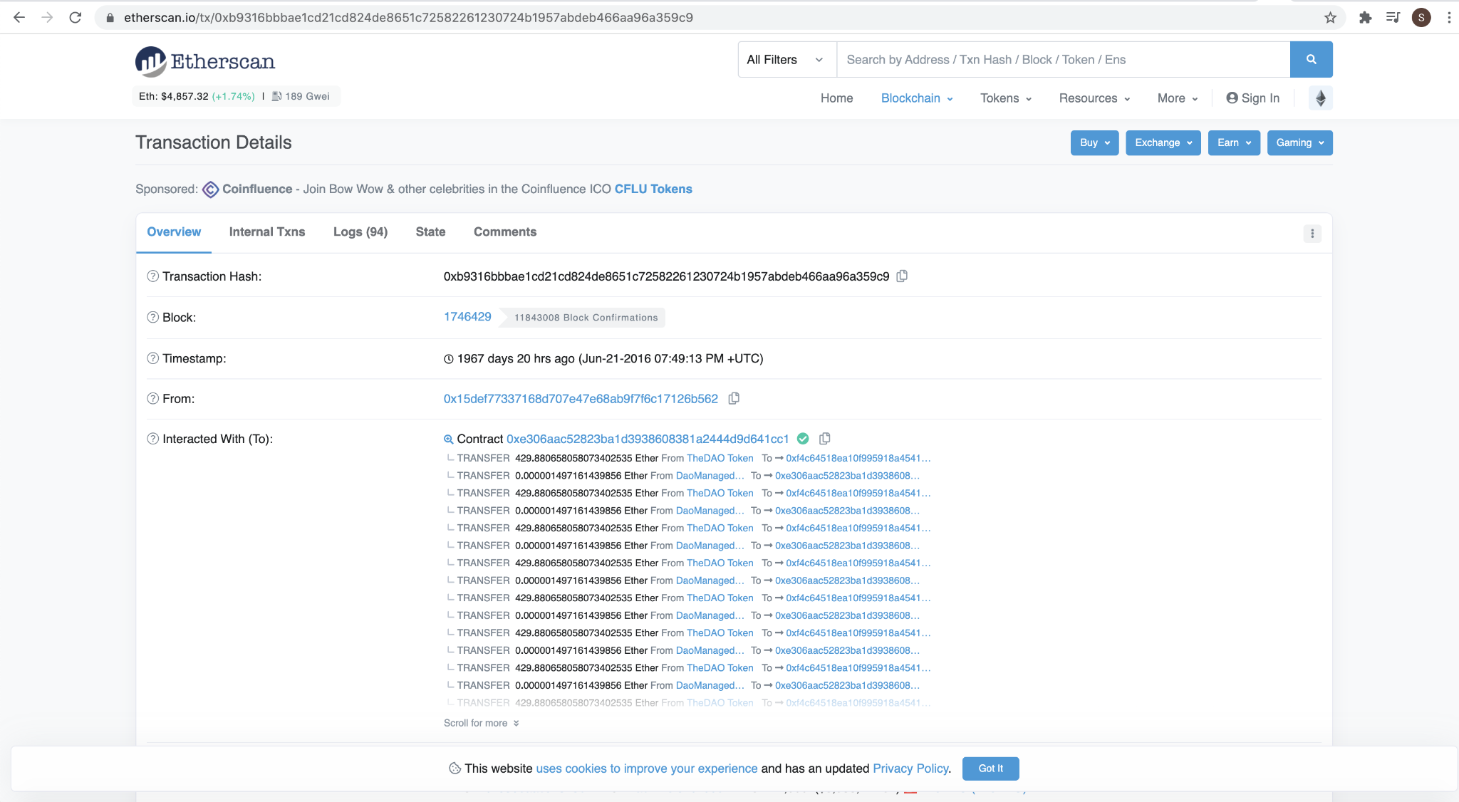

Transaction No 2

0x4fc1580e7f66c58b7c26881cce0aab9c3509afe6e507527f30566fbf8039bcd0

Ans: This is 0 value transaction from Uniswap: Deployer 2 to Uniswap V2: Router 2 with transaction fees of 0.104639238 Ether ($507.75)

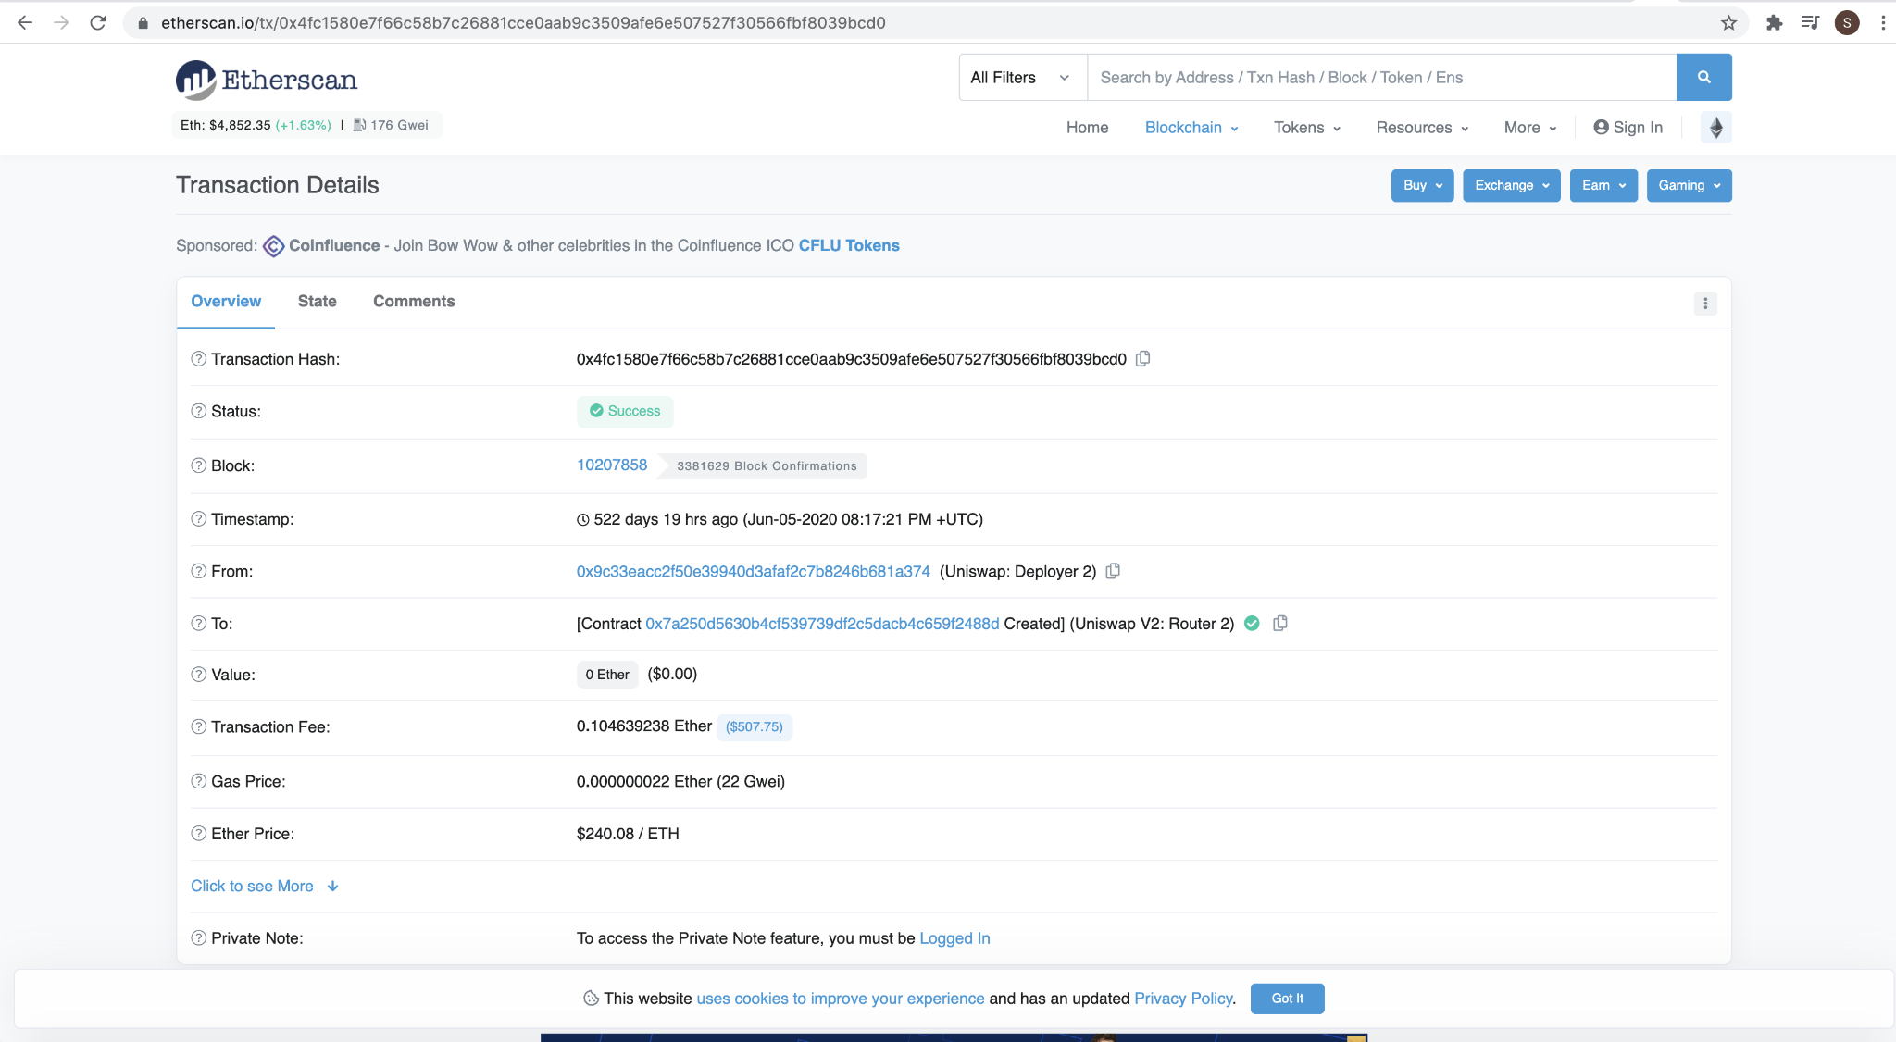

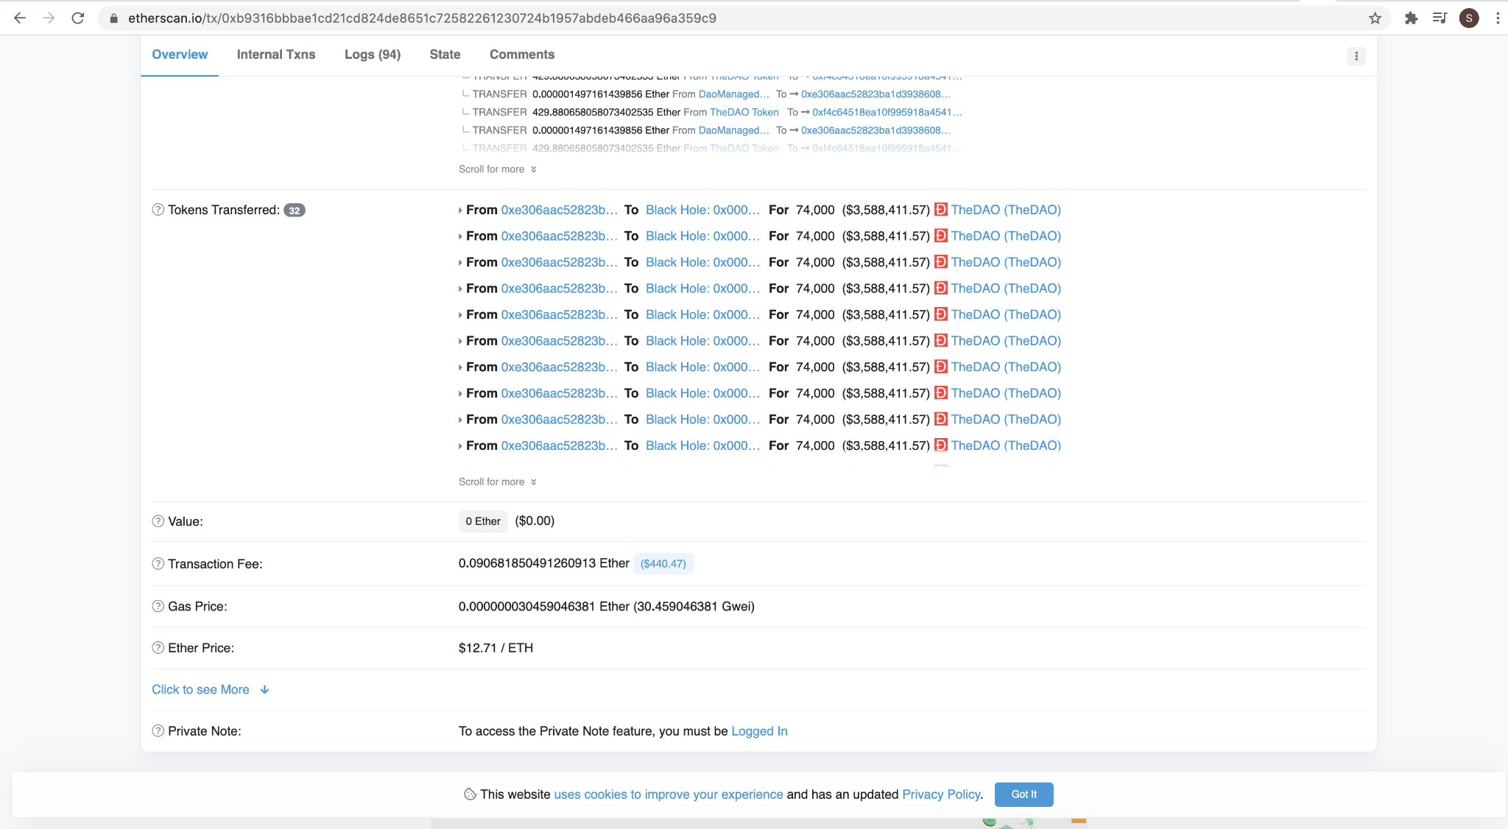

Transaction No 3

0x552bc0322d78c5648c5efa21d2daa2d0f14901ad4b15531f1ab5bbe5674de34f

Ans: This is 0 value transaction from PolyNetwork Exploiter 1 to PolyNetwork Exploiter 1 with transaction fees of 0.002404 Ether ($11.65)

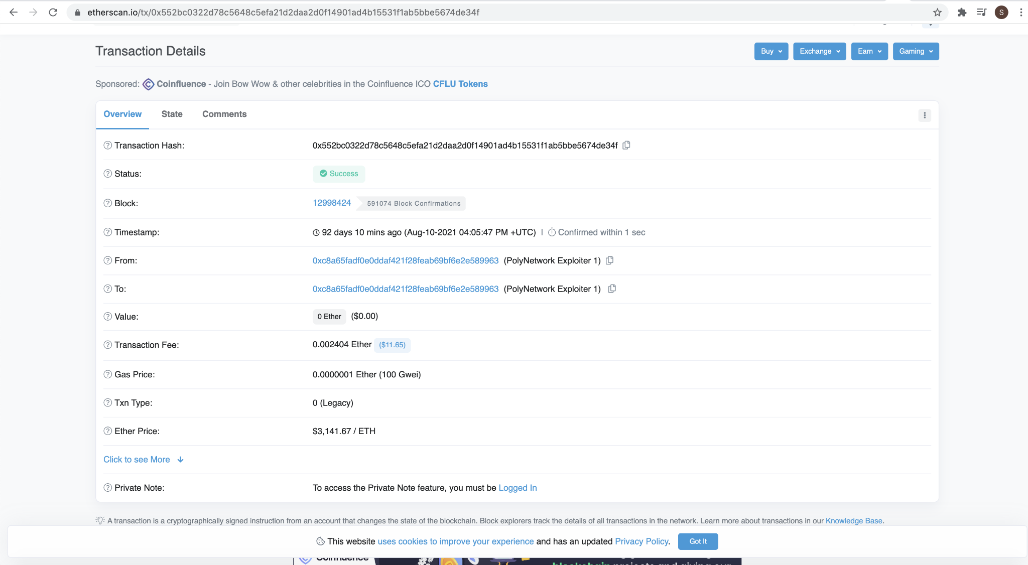

Transaction No 4

0x7a026bf79b36580bf7ef174711a3de823ff3c93c65304c3acc0323c77d62d0ed

Ans: This is 0 value transaction from PolyNetwork Exploiter 1 to Dai Stablecoin with transaction fees of 0.002104417611224222 Ether ($10.20)

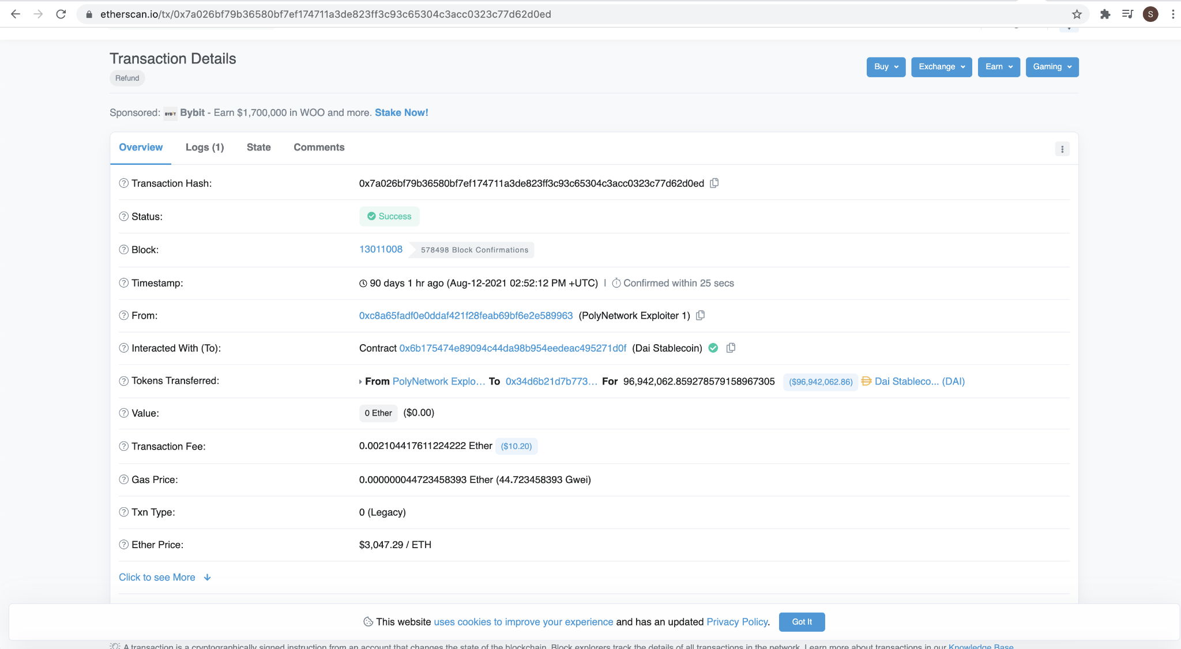

Transaction No 5

0x814e6a21c8eb34b62a05c1d0b14ee932873c62ef3c8575dc49bcf12004714eda

Ans: This is 160 Ether ($774,561.60) value transaction with transaction fees of 0.00105 Ether ($5.08)

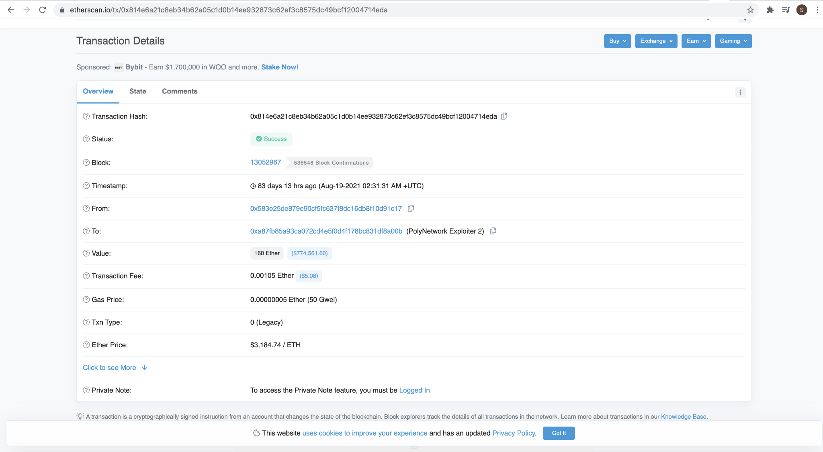

Largest Account Balance

0x00000000219ab540356cBB839Cbe05303d7705Fa

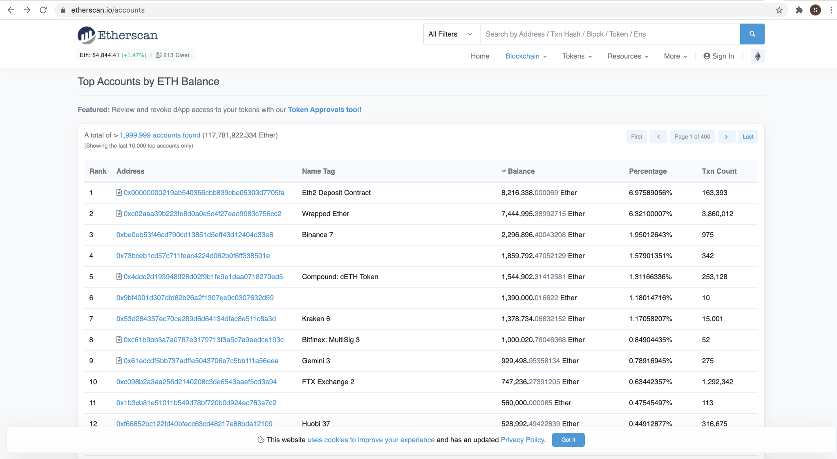

What is special about these accounts :

0x1db3439a222c519ab44bb1144fc28167b4fa6ee6

Ans : This Account is special as it seems to be doing transactions of lot of ETH standards like ERC20 Tokens, ERC721 tokens and ERC1155 tokens

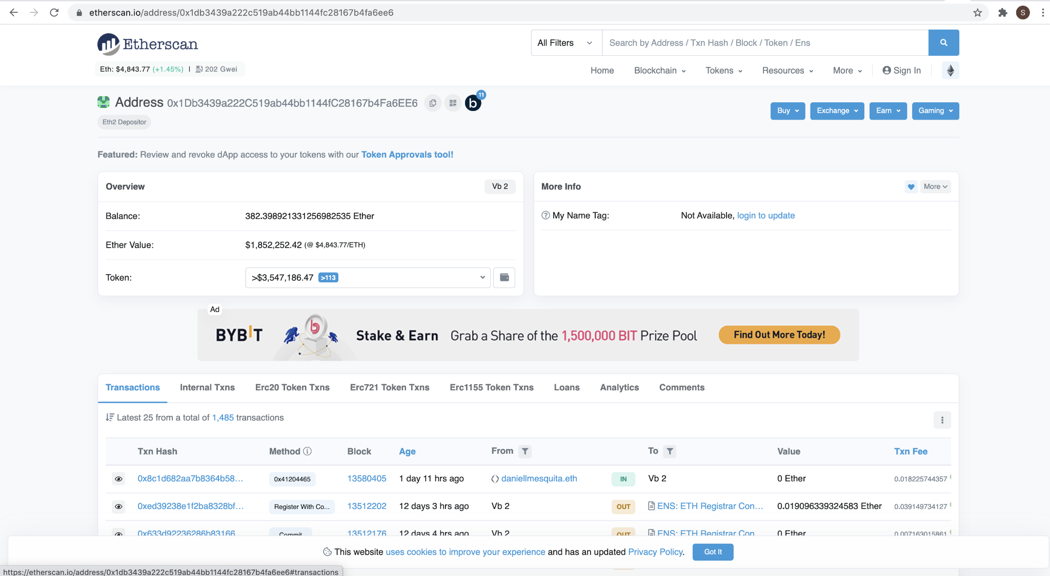

What is special about these accounts :

0x000000000000000000000000000000000000dEaD

Ans : This Account is special as it seems to be doing transactions of lot of Black Hole accounts using a variety of standards

